Target:

* Why the dispersion is parabolic around band edge?
* How the dispersion become non-parabolic away from band edge?
* What is the effective mass at high k?

## Eigen equation

Let’s begin with widely-used Kane model with four bands. The Hamiltonian matrix is



And the solution is



where 

There are four eigen values, corresponding to the energy position of the four bands.

## two band model

For the first step, I would like to simplify the discussion with two-band model, i.e., conduction band and light hole band. In this model, the light-hole band is assumed to be connected to the lowest lying conduction band, whereas the heavy-hole and split-off valence bands are connected to higher lying conduction bands. The justification of two-band model is that in Kane’s four band model, the heavy hole is decoupled from the other bands, and split-off band can be ignore if is much smaller than bandgap (i.e., ). Then the solution becomes



### Around band edge,k~0







**physical meaning of ɛ**



so a change of **ɛ will be amplified by Ep/Eg in electron energy, which is about 30.**

### Away from the band edge, i.e., at high k,

the electron energy at the conduction band is



[1]p329

x2 has the unit of energy. because Ep/Eg>>1, a small change in x^2 will be amplified by Ep/Eg in energy range.

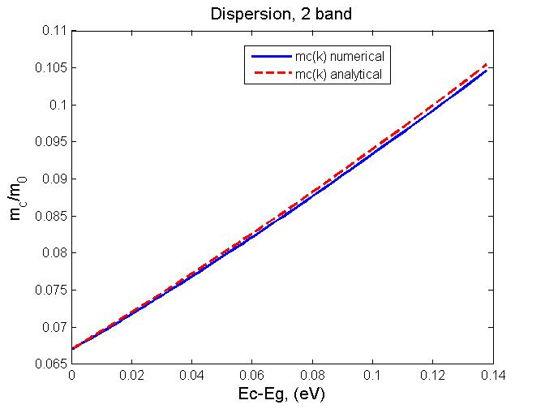 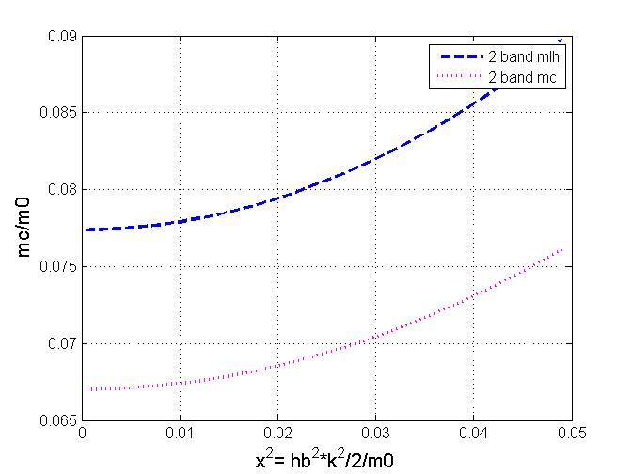

In two band model, if use the Ep parameter, the band edge effective mass of electron is 0.047, much smaller than the actually value of 0.067. This is because the EP is from 8 band model, larger than 2 band model, thus resulting in a smaller effective mass. To keep consistence in the use of 2 band model, the Ep or momentum matrix element should be inferred from the electron effective mass. However, light hole mass calculated by this 2-band Ep is smaller than the actual value, (i.e. 0.077<0.087), due to a overestimated Ep. ( the inclusion of so of reduce the Ep) .

## Four band model

Let’s get back to 4 band model



where , ,

### Around band edge, kP << Eg





For example, the Ep for 4 band and 2 band are 19.8 and **21.2**eV, lower than experimental 28.8 eV.



### Away from the band edge, ∆>>Eg, kP

This is to prove equ. (13) in E. O. Kane, "Band structure of indium antimonide", J. Phys. Chem. Solids, **1**, 249 (1957) [2]. For InSb, ∆=0.81,Eg=0.18. this is true, but not for InAs.

With the above assumption, only the term with ∆ is preserved:





This is very similar to 2-band model: 

However, this simplified solution was mistakenly used by a widely cited paper[3], in its equation (14).

### Away from the band edge, general case

The cubic function can have analytical solution.

The discriminant is always larger than zero, meaning there are three distinct real roots.



solution is as in <https://en.wikipedia.org/wiki/Cubic_function>









The analytical expression of  will be too time-consuming to worth the effort.

The numerical approach will be used to expedite the process.



**The new definition of effective mass**



**This actually allows a analytical expression!**

## check Ep







|  |  |  |  |  |  |  |
| --- | --- | --- | --- | --- | --- | --- |
|  | Eg | mc | Ep in  simple 2 band | Ep in  Kane’s 8 band | Ep in  Kane’s 2 band | true Ep |
| GaAs | 1.424 | 0.067 | 19.83 | 21.19 | 29.74 | 28.8 |
| InAs | 0.354 | 0.023 | 15.04 | 18.22 | 22.55 | 21.5 |
| GaSb | 0.73 | 0.039 | 17.99 | 21.67 | 26.98 | 27 |
| AlSb | 2.3 | 0.14 | 14.13 | 15.29 | 21.2 | 18.7 |
| average 6.1A |  |  | 15.72 | 18.39 | 23.58 | 22.4 |
| P’ |  |  | 1.175e8 |  | 1.44e8 |  |

## Appendix for band edge approximation



## New approach to calculate non-parablic effective mass

## 

In the further study, I should be able to compare my result with [4]

References

[1] P. Yu and M. U. Cardona, *Fundamentals of Semiconductors: Physics and Materials Properties*. (Springer Berlin Heidelberg, 2010).

[2] E. O. Kane, "Band structure of indium antimonide", J. Phys. Chem. Solids, **1**, 249 (1957).

[3] Y. B. Li and et al., "Infrared reflection and transmission of undoped and Si-doped InAs grown on GaAs by molecular beam epitaxy", Semicond. Sci. Technol., **8**, 101 (1993).

[4] J. R. Dixon and J. M. Ellis, "Optical Properties of n-Type Indium Arsenide in the Fundamental Absorption Edge Region", Phys. Rev., **123**, 1560 (1961).